The Bell Tower
Newsletter of the First Congregational Church of Hatfield, UCC
2023 September No. 9
Fighting the Loneliness Epidemic

My Sunday afternoons often involve leisurely reading an actual print copy of the Boston Globe. On the last Sunday of July, I read an article titled “America has a loneliness epidemic.” (https://www.bostonglobe.com/2023/07/28/opinion/religion-for-loneliness-epidemic/ ) One of the reasons it caught my eye is that one of the authors, Wendy Cadge, is a professor at my alma mater, Brandeis University, and the founder there of Chaplaincy Innovation Lab.
The article references an Advisory Report issued in May by the Surgeon General of the United States, Vivek Murthy. It declares a loneliness epidemic in America. Here is local testimony to this fact. Around 3:25 in this recording
https://www.nepm.org/podcast/valley-voices/2023-06-09/very-cold-water a very extroverted Angela Combest, a woman from Florence, shared a story on NEPM about moving to the Pioneer Valley and discovering how difficult it is to make new friends. She, obviously, is not unique. Due to this prevalence, the Surgeon General’s advisory urges groups across the nation to work toward repairing this pervasive sense of isolation.
What the two authors of this Globe article highlight is that religion was once the primary glue that held people together. It is within my own memory that I heard stories where church was once the centerpiece of a family’s life, of a community’s life. Of course, there was the time at worship, but there would also be all sorts of social activities that would bind the congregation together from children to seniors.
In the Surgeon General’s 80-page advisory, however, religion was mentioned but one time, “[a]nd that one mention is part of a list of division topics that cause polarization between individuals and communities.” (BG, 7/30/23, p. K2)
Then, in a stand-alone paragraph, they write, “No longer the salve, faith is now suspect.” The authors are knowledgeable teachers of religion. As such, they know that the words salve and salvation derive from the same Latin root, salvere, and it remains apparent still in English.
For some reason, many Christians push the idea of salvation off to the next world, leaving this one bereft of salvation. However, salvation is meant to be a worldly salve to help heal what ails this world. The words are literally connected in their origin.
When our nation was in gestation, when our religious forebears, the Puritans, were still on the other shore, John Winthrop delivered a sermon before the ship Arbella sailed to settle Boston. He famously quoted the biblical verse of “a city on a hill,” an experiment and example for all the world to see of what is possible when faith is lived, when the ideal of salvation is not postponed but is a salve. Ever since, our theology has emphasized the idea of progress in the world, of making the world better than it was.
For religions to now be mentioned in an official government advisory as not in any part a salve to heal our nation’s divisions, but as a principal cause of those divisions, something has gone horribly wrong. The article protests by sharing examples of religions healing divisions and acting as a salve, concluding: “Faith communities can answer by opening their eyes, ears, hearts and doors. There is not one village, town or city where people aren’t suffering from loneliness; while some of them regularly attend services, the majority do not. Look for them. Engage them. Serve them.”
One way in which we can join this protest is through the discussion later in September led by Rev. Shannon Farrand-Bernardin on how to expand our community by trying to be more engaged with young adults. I am looking forward to learning more about this because I believe that our church model is well suited to engage and serve them. We are forward looking in our theology and open to new ideas and practices. We also provide a big tent because we respect each person’s conscience, realizing that there are multiple ways in which to live a moral and spiritual life – together. And together is a way in which we can combat the loneliness epidemic.

SEPTEMBER EVENTS
Tue. 5th | Rev. Randy will attend the monthly meeting of the Association Committee on Ministry at 5:45pm.
Sun. 10th | Homecoming Sunday. Worship Service at 11:00am not the usual 9:30am. Suppers Committee Dinner at noon.
Mon. 11th | Online Exploring the Bible study group from 7 – 8:00pm.
Tue. 12th | Rev. Randy will attend the Hampshire Clergy Gathering from 12 – 1:00pm in Hadley.
Mon. 18th | Monthly meeting of the Board of Trustees at 7:00pm.
Mon. 25th | Monthly meeting of the Board of Deacons in person at the church at 6:30pm.
Tue. 26th | Our congregation will host Rev. Shannon Farrand-Bernardin, Amherst College Student Care Coordinator, for a talk on young adults and the church, beginning at 7:00pm.
Wed. 27th | Rev. Randy will attend the monthly meeting of HEADS Up at 6:30pm.
Sat. 30th | Chicken Barbecue from 4:30 – 6:30pm.

REGULAR GATHERINGS
Sundays: Worship Service begins at 9:30am online and in person. Sunday School begins after the children’s sermon during the worship Service.
Mondays: The Joyful Ringers Bell Choir rehearses from 6 - 8:00pm.
Tuesdays: Yoga classes are offered every Tuesday in the church parlor at 5:30pm.
Thursdays: Choir rehearses in the parlor at 7:00pm, except July and August.
HOMECOMING SUNDAY
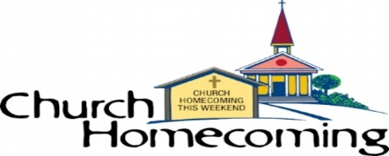
Please mark September 10th on your calendars so that you can attend Homecoming Sunday. On this day, our worship Service will begin at the special time of 11:00am. It will be followed by a Suppers Committee Dinner of turkey and stuffing, ham and pineapple and cherries, mashed potatoes, vegetable and salad! This day will give us the chance to mingle with one another as we transition from summer to fall. This is a perfect opportunity to get back in the swing of church life if that may have dropped off a bit over the summer. It’s also a wonderful occasion to invite someone you know to come to church with you and let them get to know us at worship and in person. I know there are many out there who do not attend church anywhere. Maybe they are fine without sharing in what church offers, but some of them may find church a true blessing. I do hope you’ll think about coming and also inviting others as well to our Homecoming Sunday.
ONLINE BIBLE STUDY GROUP
Our online Bible study group is reading from the Acts of the Apostles and then the Gospel of John. If you would like to join us as we read of the early days of the church and then of John’s unique take on Jesus’ life and ministry, we would love to have you join us. Let’s read, study and discuss the book that literally has changed the world. Send an email to randyc1897@gmail.com for the login. We meet on alternate weeks for one hour.
JOYFUL RINGERS BELL CHOIR
The Joyful Ringers rehearse on Mondays from 6 – 8:00pm. Anyone who is interested is welcome to become a part of the Bell Choir. Younger or older, church member or bell enthusiast, experienced or novice, we would love it if you would come forward and add the gift of more music to our sanctuary. If you may be interested, please reach out to Rev. Randy at randyc1897@gmail.com or Sue M., the Music Committee Chair.
Also, we do have a set of chimes that the children may play at worship. If your daughter or son may be interested in learning how to play the chimes, we would love to hear from you. It may even be fun for them.
CROP HUNGER WALK
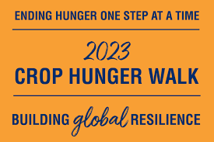
The CROP Hunger Walk will take place in Orange on Sunday, October 1st. However, before we get to that point, we need to start thinking about fundraising for the good work of Church World Services. We have received donation envelopes for our team members so that they may begin collecting donations. Would you like to be a part of our congregation’s team? Would you like to walk with hundreds of others who are committed to the good work of helping people in need locally and around the globe? Would you like to make a donation to this worthy organization? These are the good things that churches should do. You can become a team member or make a donation by speaking with Amy N., Benevolence Chair, or by visiting https://events.crophungerwalk.org/2023/rev-randolph-calvo-2.
The CROP Walks were the first “walks.” The model has been copied by many other worthy causes, but the CROP Walks are the oldest. It is important for people to see in various hosting communities that people are out walking in solidarity with people in need throughout the world. The slogan is “We walk because they walk.” In many poor countries, people must walk long distances for water, food, medical treatment and the such. The walks are reminders to everyone who sees them of these too often forgotten populations.
NEW MEMBERS MEETING?
Now that we are entering the season of Fall it is time to ask if any of the friends of the congregation or new attendees may be interested in learning about full membership at our church. Whoever you are, you are welcome at our church. However, some choose to go further and covenant with the congregation and the congregation with them. If you would like to learn more about this or ask your questions, please let Rev. Randy know of your interest. A tentative date for this meeting is Thursday, September 21st at 7:00pm.
CHRISTMAS BAZAAR and CRAFT FAIR
We are a long way off from December’s fundraiser, but if you have some extra downtime during these summer months, would you consider working on your special craft talents so that they may be shared with the church at the Bazaar. People love handmade crafts. Thank you for whatever you can do for our church.
SOCIAL MEDIA
Don’t forget to check in at our website and FaceBook page. The links are directly below. They are updated several times each week and often share information from the larger church that we may not know of otherwise. If you have a knack for working through social media and you would like to help us expand our presence, please let us know.
CHICKEN BARBECUE
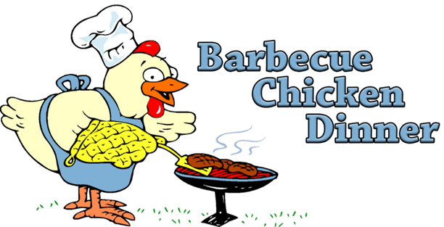
The Fall Chicken Barbecue will take place at the church on Saturday, September 30th. This is a take-out only dinner. Meals may be picked up between 4:30 and 6:30pm. The cost per ticket is $17. Tickets may be purchased at church or by calling 413-247-5604 or 413-247-5905.
If you could help work this important fundraiser of our church, the volunteer clipboard will be available on Sunday mornings or you may reach out to Amy N. or Rev. Randy. Thank you for your support.

GIFT CARDS
Big Y gift card sales are a continuing fundraiser of our congregation. Please contact Linda M. if you would like to purchase any. The church earns 5% on all sales. Thank you.

CONTACT INFO: HATFIELD CONGREGATIONAL CHURCH
Website: www.hatfieldchurch.org Facebook: www.facebook.com/First-Congregational-Church-of-Hatfield-UCC
Pastor: Rev. Randy Calvo 413-824-1630 randyc1897@gmail.com
Music Minister: Anthony Tracia anthonytracia@gmail.com
Committee Chairpersons:
Benevolence, Amy N. | Music Committee, Sue M.
Christian Education, Anita W. | Real Folks Society, Martha Z.
Church Moderator, Jonathan B. | Trustees, Ed M.
Deacons, Jeff F.

Young Adults: What Brings Them to Church & Why They Stay
Our churches are located in communities that host or are near to renowned preparatory schools, colleges and universities. We live in a region surrounded by higher education institutions. And yet, many of our congregations look like young adult deserts.
Is this an inevitable fact of changing times, or is there a way to bring young adults into our communities?
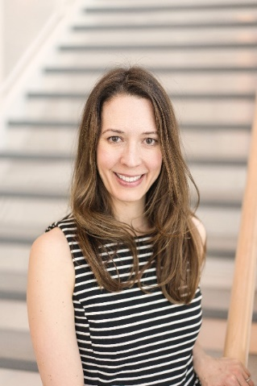(Photo by Jennifer Sanders)
Rev. Shannon Farrand-Bernardin, Student Care Coordinator of Amherst College, and former Assistant Director of Religious & Spiritual Life and Christian Chaplain at Amherst College, and Assistant Chaplain of Christian & Interfaith Life at Carleton College, will share reflections about what brings young adults to churches, why they continue attending (or don't), and offer suggestions for creating vibrant and welcoming faith communities that are hospitable to teens, college students, and young adults.
This talk will be hosted by the First Congregational Church of Hatfield, United Church of Christ and is open to all in the Conference who are interested in reaching out to young adults. The talk will begin at 7:00pm on Tuesday, September 26th and also will be live-streamed. If you would like to receive a link to the live-stream, please send a request to randyc1897@gmail.com.

